Training Providers

On-Demand Home Services in Kathmandu

Prepared for: Sriyog Consulting
Prepared by: Sadikshya Karki

Date: June 2026
Research Scope: Kathmandu, Nepal

1. Introduction
The growth of on-demand home services in Nepal has created a rising need for skilled workers who can deliver quality services directly at the customer's doorstep. To meet this demand, a wide network of training providers has emerged across the Kathmandu district, offering hands-on courses in areas ranging from technical repairs and construction work to beauty, wellness, and domestic care.
This report maps and analyzes the training providers identified in the Kathmandu district for 40 service categories relevant to the on-demand home services sector. The findings are drawn from primary research and publicly available information gathered from training institution websites, online platforms, and service provider portals.

2. Scope of the Study
This study covers 40 service categories that are commonly listed under on-demand home service platforms in Nepal. For each service category, training providers were identified based in or accessible from the Kathmandu district, along with key details such as provider type, website, and whether training is offered on a paid or free or subsidized basis.
The data for this report was gathered through desktop research conducted in June 2026. Training providers were identified by searching for institutions offering courses or programs relevant to the selected service categories. All information was verified using official institutional websites to ensure accuracy and reliability.
Only providers with a verifiable online presence and clearly relevant training programs were included in the dataset. Institutions without sufficient or confirmable information were excluded and marked as Not Found.
The classification of training providers was based on two main criteria:
- Organizational type
- Fee structure

3. Training Providers Dataset
The following table presents the complete dataset of training providers identified for each service category. The heatmap after the table provides a visual overview of which institutions cover which services, allowing a quick comparison of provider portfolios across all 40 categories.
Table 1: Complete List of Training Providers
No. | Service Category | Institution Name | Type | Fee Structure
1 | Deep Cleaning | Multiple Facility Service | Training Provider | Paid
2 | Deep Cleaning | IHTS Nepal | Training Institute | Paid
3 | Deep Cleaning | Sajilo Sewa | Training Provider | Paid
4 | Deep Cleaning | Kucho | Training Provider | Paid
5 | Deep Cleaning | KTS Nepal | Training Institute | Paid
6 | Deep Cleaning | Skill Based TC | Training Center | Paid
7 | Deep Cleaning | Nepal CTS | Training Institute | Paid
8 | Deep Cleaning | Kamkhya OVS | Training Provider | Paid
9 | Deep Cleaning | Talim Kendra | Training Center | Free or Subsidized
10 | Garden Care | Kumari Flora | Training Provider | Paid
11 | Garden Care | Edusanjal | Online Platform | Paid
12 | Garden Care | Khojnu | Online Platform | Paid
13 | Garden Care | Multiple Facility Service | Training Provider | Paid
14 | Garden Care | eCourses Nepal | Online Platform | Paid
15 | Masonry Repair | F-Skill Nepal | Training Institute | Free or Subsidized
16 | Masonry Repair | ISET Nepal | Training Institute | Free or Subsidized
17 | Masonry Repair | Kamkhya OVS | Training Provider | Paid
18 | Masonry Repair | NMSPL | Training Institute | Free or Subsidized
19 | Masonry Repair | Trade Link Technical Training Institute | Training Institute | Paid
20 | Masonry Repair | AIM Technical Institute | Training Institute | Paid
21 | Masonry Repair | Global Reliance TC | Training Center | Paid
22 | Masonry Repair | KIEC | Training Institute | Paid
23 | Masonry Repair | UTIOC | Training Institute | Free or Subsidized
24 | Plumbing Repair | Sajilo Sewa | Training Provider | Paid
25 | Plumbing Repair | Kamkhya OVS | Training Provider | Paid
26 | Plumbing Repair | NMSPL | Training Institute | Free or Subsidized
27 | Plumbing Repair | Skill Nepal | Training Institute | Paid
28 | Plumbing Repair | Apex Skills Academy | Training Institute | Paid
29 | Plumbing Repair | Technical Sewa | Training Provider | Paid
30 | Plumbing Repair | Trade Link Technical Training Institute | Training Institute | Paid
31 | Plumbing Repair | Kathmandu Technician | Training Provider | Paid
32 | Plumbing Repair | AIM Technical Institute | Training Institute | Paid
33 | Plumbing Repair | Global Reliance TC | Training Center | Paid
34 | Plumbing Repair | KIEC | Training Institute | Paid
35 | Plumbing Repair | UTIOC | Training Institute | Free or Subsidized
36 | Plumbing Repair | Talim Kendra | Training Center | Free or Subsidized
37 | Electrical Repair | Sajilo Sewa | Training Provider | Paid
38 | Electrical Repair | Kamkhya OVS | Training Provider | Paid
39 | Electrical Repair | Skill Nepal | Training Institute | Paid
40 | Electrical Repair | Apex Skills Academy | Training Institute | Paid
41 | Electrical Repair | Technical Sewa | Training Provider | Paid
42 | Electrical Repair | F-Skill Nepal | Training Institute | Free or Subsidized
43 | Electrical Repair | NMSPL | Training Institute | Free or Subsidized
44 | Electrical Repair | Trade Link Technical Training Institute | Training Institute | Paid
45 | Electrical Repair | AIM Technical Institute | Training Institute | Paid
46 | Electrical Repair | Blue Diamond Service Center | Training Provider | Paid
47 | Electrical Repair | NobleProg Nepal | Training Provider | Paid
48 | Electrical Repair | Global Reliance TC | Training Center | Paid
49 | Electrical Repair | UTIOC | Training Institute | Free or Subsidized
50 | Electrical Repair | Talim Kendra | Training Center | Free or Subsidized
51 | Carpentry | NMSPL | Training Institute | Free or Subsidized
52 | Carpentry | Trade Link Technical Training Institute | Training Institute | Paid
53 | Carpentry | Global Reliance TC | Training Center | Paid
54 | Carpentry | PMTC | Training Institute | Paid
55 | Carpentry | UTIOC | Training Institute | Free or Subsidized
56 | Carpentry | Peace Technical Institute | Training Institute | Paid
57 | Washing Machine Repair | Apex Skills Academy | Training Institute | Paid
58 | Washing Machine Repair | Technical Sewa | Training Provider | Paid
59 | Washing Machine Repair | Mobile Training Institute | Training Institute | Paid
60 | Washing Machine Repair | Kathmandu Technician | Training Provider | Paid
61 | Washing Machine Repair | Blue Diamond Service Center | Training Provider | Paid
62 | EV Charger Installation | Kathmandu Technician | Training Provider | Paid
63 | EV Charger Installation | Mobile Training Institute | Training Institute | Paid
64 | EV Charger Installation | Abhiyantrika Karmashala | Training Institute | Paid
65 | EV Charger Installation | Nepal TVET | Training Institute | Free or Subsidized
66 | EV Charger Installation | NobleProg Nepal | Training Provider | Paid
67 | AC Services | Skill Nepal | Training Institute | Paid
68 | AC Services | Apex Skills Academy | Training Institute | Paid
69 | AC Services | Technical Sewa | Training Provider | Paid
70 | AC Services | Mobile Training Institute | Training Institute | Paid
71 | AC Services | NepGuru | Training Provider | Paid
72 | AC Services | NMSPL | Training Institute | Free or Subsidized
73 | AC Services | Modern Electronics | Training Provider | Paid
74 | AC Services | Trade Link Technical Training Institute | Training Institute | Paid
75 | AC Services | Kathmandu Technician | Training Provider | Paid
76 | AC Services | Blue Diamond Service Center | Training Provider | Paid
77 | Painting | Kamkhya OVS | Training Provider | Paid
78 | Painting | Trade Link Technical Training Institute | Training Institute | Paid
79 | Painting | AIM Technical Institute | Training Institute | Paid
80 | Painting | Global Reliance TC | Training Center | Paid
81 | Painting | Multiple Facility Service | Training Provider | Paid
82 | Painting | UTIOC | Training Institute | Free or Subsidized
83 | Packing and Moving | Not Found | Not Identified | Not Identified
84 | AirBnB Maintenance | Nepal CTS | Training Institute | Paid
85 | AirBnB Maintenance | Talim Kendra | Training Center | Free or Subsidized
86 | AirBnB Maintenance | KTS Nepal | Training Institute | Paid
87 | AirBnB Maintenance | IHTS Nepal | Training Institute | Paid
88 | AirBnB Maintenance | Skill Based TC | Training Center | Paid
89 | Bridal Makeup | Skill Nepal | Training Institute | Paid
90 | Bridal Makeup | Veda Institute Nepal | Training Institute | Paid
91 | Bridal Makeup | Zoom Beauty Academy | Training Institute | Paid
92 | Bridal Makeup | ISAS Nepal | Training Institute | Paid
93 | Bridal Makeup | Murarkey | Training Provider | Paid
94 | Bridal Makeup | Bliss Academy Nepal | Training Institute | Paid
95 | Bridal Makeup | SOBS Beauty Academy | Training Institute | Paid
96 | Bridal Makeup | PB Academy | Training Institute | Paid
97 | RO Water Purifying | Apex Skills Academy | Training Institute | Paid
98 | RO Water Purifying | Technical Sewa | Training Provider | Paid
99 | RO Water Purifying | Mobile Training Institute | Training Institute | Paid
100 | RO Water Purifying | Blue Diamond Service Center | Training Provider | Paid
101 | Refrigerator Repair | Skill Nepal | Training Institute | Paid
102 | Refrigerator Repair | Apex Skills Academy | Training Institute | Paid
103 | Refrigerator Repair | Technical Sewa | Training Provider | Paid
104 | Refrigerator Repair | Mobile Training Institute | Training Institute | Paid
105 | Refrigerator Repair | NepGuru | Training Provider | Paid
106 | Refrigerator Repair | NMSPL | Training Institute | Free or Subsidized
107 | Refrigerator Repair | Modern Electronics | Training Provider | Paid
108 | Refrigerator Repair | Kathmandu Technician | Training Provider | Paid
109 | CCTV Services | Mobile Training Institute | Training Institute | Paid
110 | CCTV Services | NepGuru | Training Provider | Paid
111 | CCTV Services | Modern Electronics | Training Provider | Paid
112 | CCTV Services | NobleProg Nepal | Training Provider | Paid
113 | Modular Kitchen | NepGuru | Training Provider | Paid
114 | Modular Kitchen | IIFT Nepal | Training Institute | Paid
115 | Modular Kitchen | Kantipur Technical Institute | Training Institute | Paid
116 | Home Renovation | NepGuru | Training Provider | Paid
117 | Home Renovation | Broadway Infosys | Training Institute | Paid
118 | Home Renovation | KIEC | Training Institute | Paid
119 | Pest Control | Training Cred | Online Platform | Paid
120 | Pest Control | Multiple Facility Service | Training Provider | Paid
121 | Drywall Repair | NMSPL | Training Institute | Free or Subsidized
122 | Drywall Repair | Trade Link Technical Training Institute | Training Institute | Paid
123 | Drywall Repair | Global Reliance TC | Training Center | Paid
124 | Drywall Repair | Broadway Infosys | Training Institute | Paid
125 | Drywall Repair | KIEC | Training Institute | Paid
126 | Salon at Home | Skill Nepal | Training Institute | Paid
127 | Salon at Home | Veda Institute Nepal | Training Institute | Paid
128 | Salon at Home | Zoom Beauty Academy | Training Institute | Paid
129 | Salon at Home | ISAS Nepal | Training Institute | Paid
130 | Salon at Home | Bliss Academy Nepal | Training Institute | Paid
131 | Salon at Home | SOBS Beauty Academy | Training Institute | Paid
132 | Salon at Home | PB Academy | Training Institute | Paid
133 | Tiling | Kamkhya OVS | Training Provider | Paid
134 | Tiling | Trade Link Technical Training Institute | Training Institute | Paid
135 | Tiling | Global Reliance TC | Training Center | Paid
136 | Tiling | Broadway Infosys | Training Institute | Paid
137 | Tiling | KIEC | Training Institute | Paid
138 | Tiling | UTIOC | Training Institute | Free or Subsidized
139 | Chef at Home | Training Center Nepal | Training Center | Paid
140 | Chef at Home | Kamkhya OVS | Training Provider | Paid
141 | Chef at Home | Radisson Hotel Training | Training Provider | Paid
142 | Chef at Home | IHTS Nepal | Training Institute | Paid
143 | Chef at Home | PMTC | Training Institute | Paid
144 | Chef at Home | Talim Kendra | Training Center | Free or Subsidized
145 | Home Automation | NepGuru | Training Provider | Paid
146 | Home Automation | The Knowledge Academy | Training Institute | Paid
147 | Home Automation | Mobile Training Institute | Training Institute | Paid
148 | Home Automation | NobleProg Nepal | Training Provider | Paid
149 | Home Automation | Technologics | Training Provider | Paid
150 | Home Automation | Saarthi Academy | Training Institute | Paid
151 | Parqueting | KIEC | Training Institute | Paid
152 | Parqueting | UTIOC | Training Institute | Free or Subsidized
153 | Parqueting | Skill Nepal | Training Institute | Paid
154 | Indoor Planting | Kumari Flora | Training Provider | Paid
155 | Indoor Planting | Edusanjal | Online Platform | Paid
156 | Indoor Planting | Khojnu | Online Platform | Paid
157 | Spa at Home | Veda Institute Nepal | Training Institute | Paid
158 | Spa at Home | Zoom Beauty Academy | Training Institute | Paid
159 | Spa at Home | ISAS Nepal | Training Institute | Paid
160 | Spa at Home | SOBS Beauty Academy | Training Institute | Paid
161 | Spa at Home | AIPA | Training Institute | Paid
162 | Spa at Home | TIBSA | Training Institute | Paid
163 | Spa at Home | Mandala Yoga Retreat | Training Provider | Paid
164 | Spa at Home | Mandala Yoga Studio | Training Provider | Paid
165 | Physiotherapy | Veda Institute Nepal | Training Institute | Paid
166 | Physiotherapy | HRDRI Nepal | Training Institute | Paid
167 | Handyman | Skill Nepal | Training Institute | Paid
168 | Handyman | Apex Skills Academy | Training Institute | Paid
169 | Handyman | UTIOC | Training Institute | Free or Subsidized
170 | Handyman | Global Reliance TC | Training Center | Paid
171 | Handyman | NMSPL | Training Institute | Free or Subsidized
172 | Handyman | Trade Link Technical Training Institute | Training Institute | Paid
173 | Handyman | Peace Technical Institute | Training Institute | Paid
174 | Massage Therapy | Veda Institute Nepal | Training Institute | Paid
175 | Massage Therapy | AIPA | Training Institute | Paid
176 | Massage Therapy | TIBSA | Training Institute | Paid
177 | Massage Therapy | Natural Yoga Nepal | Training Provider | Paid
178 | Massage Therapy | Mandala Yoga Retreat | Training Provider | Paid
179 | Massage Therapy | Mandala Yoga Studio | Training Provider | Paid
180 | Water Tank Cleaning | Kathmandu Technician | Training Provider | Paid
181 | Water Tank Cleaning | NMSPL | Training Institute | Free or Subsidized
182 | Water Tank Cleaning | Skill Nepal | Training Institute | Paid
183 | Water Tank Cleaning | UTIOC | Training Institute | Free or Subsidized
184 | Water Tank Cleaning | Apex Skills Academy | Training Institute | Paid
185 | Aluminium Fabrication | Apex Skills Academy | Training Institute | Paid
186 | Aluminium Fabrication | Trade Link Technical Training Institute | Training Institute | Paid
187 | Aluminium Fabrication | AIM Technical Institute | Training Institute | Paid
188 | Aluminium Fabrication | Global Reliance TC | Training Center | Paid
189 | Aluminium Fabrication | UTIOC | Training Institute | Free or Subsidized
190 | Aluminium Fabrication | Peace Technical Institute | Training Institute | Paid
191 | False Ceiling | NMSPL | Training Institute | Free or Subsidized
192 | False Ceiling | Trade Link Technical Training Institute | Training Institute | Paid
193 | False Ceiling | Global Reliance TC | Training Center | Paid
194 | False Ceiling | Broadway Infosys | Training Institute | Paid
195 | False Ceiling | KIEC | Training Institute | Paid
196 | Computer Repair | Training Center Nepal | Training Center | Paid
197 | Computer Repair | Apex Skills Academy | Training Institute | Paid
198 | Computer Repair | Technical Sewa | Training Provider | Paid
199 | Computer Repair | Mobile Training Institute | Training Institute | Paid
200 | Computer Repair | NepGuru | Training Provider | Paid
201 | Computer Repair | Modern Electronics | Training Provider | Paid
202 | Computer Repair | Kantipur Technical Institute | Training Institute | Paid
203 | Geyser Repair | Apex Skills Academy | Training Institute | Paid
204 | Geyser Repair | Mobile Training Institute | Training Institute | Paid
205 | Geyser Repair | Blue Diamond Service Center | Training Provider | Paid
206 | Chimney Repair | Blue Diamond Service Center | Training Provider | Paid
207 | Tree Cutting and Pruning | The Knowledge Academy | Training Institute | Paid
208 | Septic Tank Cleaning | Kathmandu Technician | Training Provider | Paid
209 | Septic Tank Cleaning | NMSPL | Training Institute | Free or Subsidized
210 | Septic Tank Cleaning | Skill Nepal | Training Institute | Paid
211 | Septic Tank Cleaning | UTIOC | Training Institute | Free or Subsidized
212 | Septic Tank Cleaning | Apex Skills Academy | Training Institute | Paid
213 | Pet Grooming | eCourses Nepal | Online Platform | Paid
214 | Pet Grooming | Canine Companions Nepal | Training Provider | Paid
215 | Lift and Elevator Repair | OSHA Nepal | Training Institute | Paid

The heatmap below confirms that a small group of institutions, including Apex Skills Academy, NMSPL, UTIOC, Trade Link Technical Training Institute, and Skill Nepal, cover the widest range of services. Most other providers are specialized, covering only two to four service areas. This concentration of broad-coverage providers means that losing any one of these key institutions would significantly reduce training availability across several categories simultaneously.

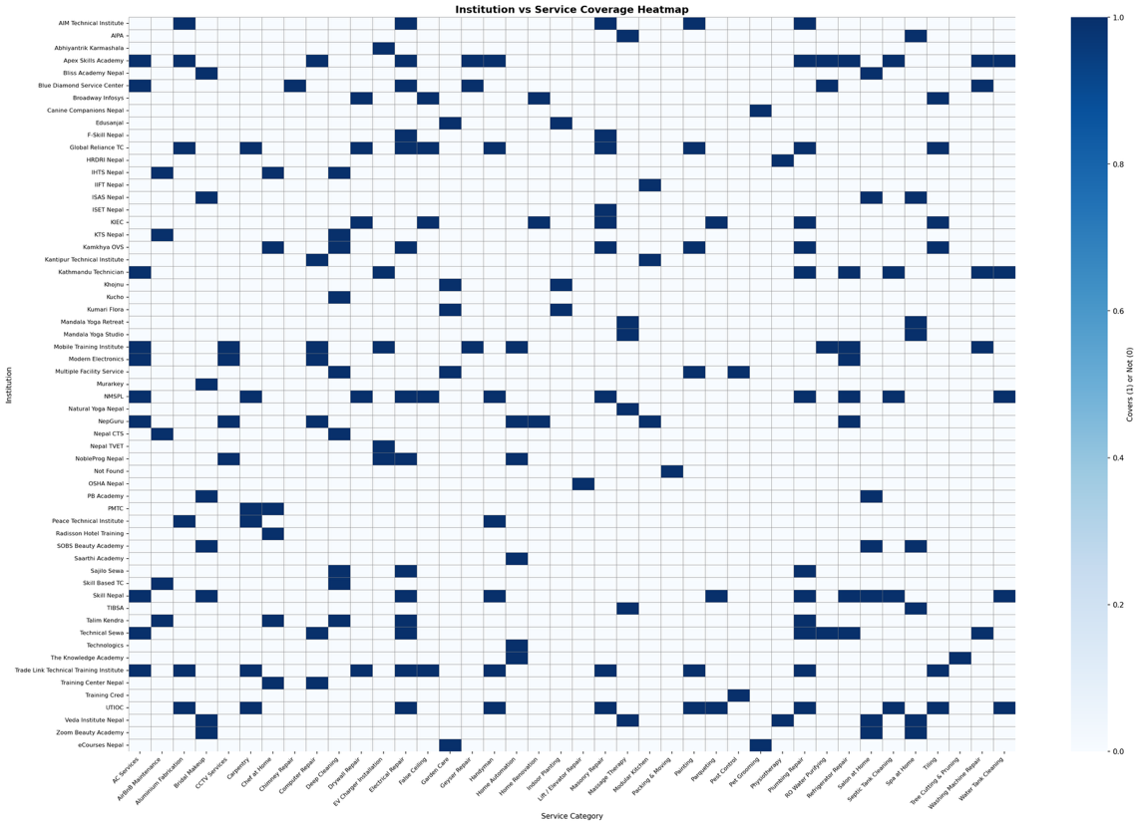
Figure 1: Institution vs Service Coverage Heatmap

4. Key Findings

4.1 Overall Training Landscape
A total of 215 training provider listings were recorded across the 40 service categories, representing 55 unique training providers. Many institutes offer training across multiple service areas. The chart below shows how provider coverage is distributed across all service categories, making it easy to spot which areas are well served and which are underrepresented.
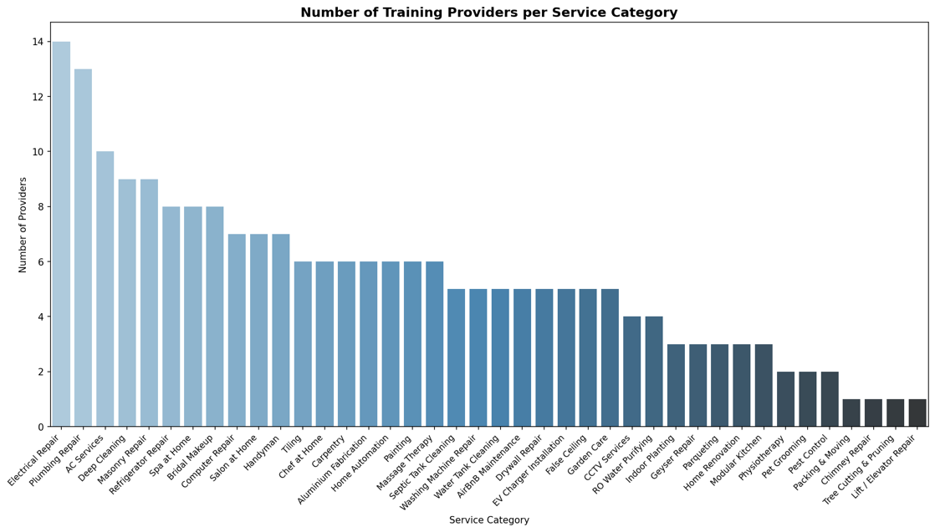
Figure 2: Number of Training Providers per Service Category
Electrical Repair leads with 14 providers, followed closely by Plumbing Repair with 13 and AC Services with 10. These three categories reflect strong market demand for technical services in urban households. On the other end, Chimney Repair, Tree Cutting and Pruning, and Lift and Elevator Repair each have only a single identified provider, pointing to clear gaps in the training landscape.

4.2 Distribution by Provider Type
The identified providers span several organizational categories. Training institutes form the largest segment, followed by training providers, training centers, and online platforms. The distinction between a training institute and a training provider is primarily operational: institutes tend to offer structured curricula with certification, while providers are often industry practitioners who offer practical, skill-focused programs.
Table 2: Distribution of Training Providers by Organizational Type
No. | Provider Type | Count
1 | Training Institute | 127
2 | Training Provider | 61
3 | Training Center | 19
4 | Online Platform | 7

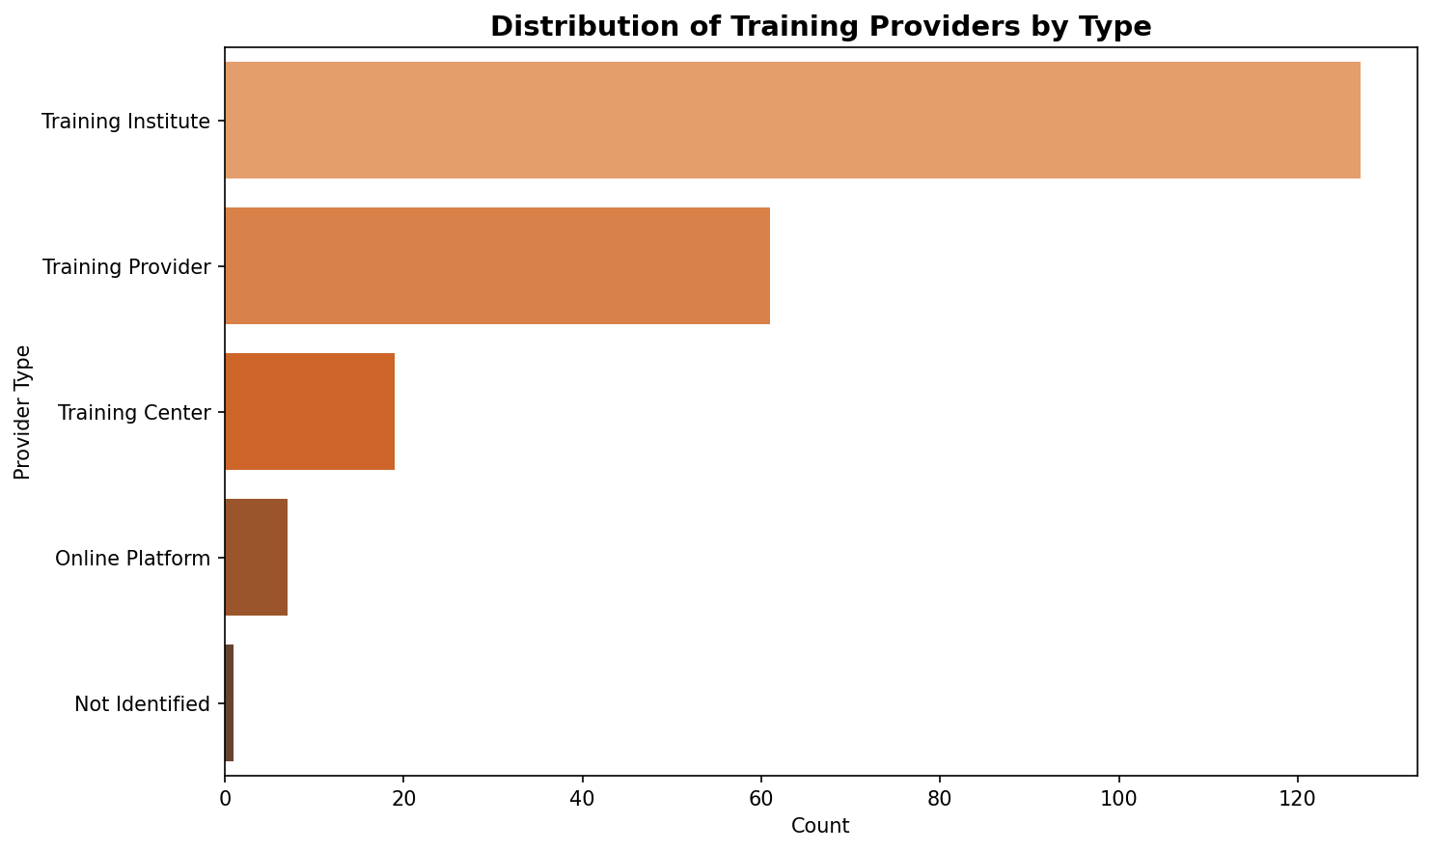
Figure 3: Distribution of Training Providers by Type
Training institutes account for most listings, reflecting a preference for structured, certification-backed learning pathways in the Kathmandu market. Online platforms remain the smallest segment, suggesting that digital vocational training has not yet gained significant traction for home service skills in Nepal.

4.3 Free and Subsidized Training Availability
Free or subsidized training options were identified for 31 entries across multiple service categories. These programs are primarily offered by government-affiliated or semi-government institutions such as NMSPL, UTIOC, F-Skill Nepal, ISET Nepal, and Talim Kendra. The pie chart below shows the overall split between paid and free training across all 215 listings.
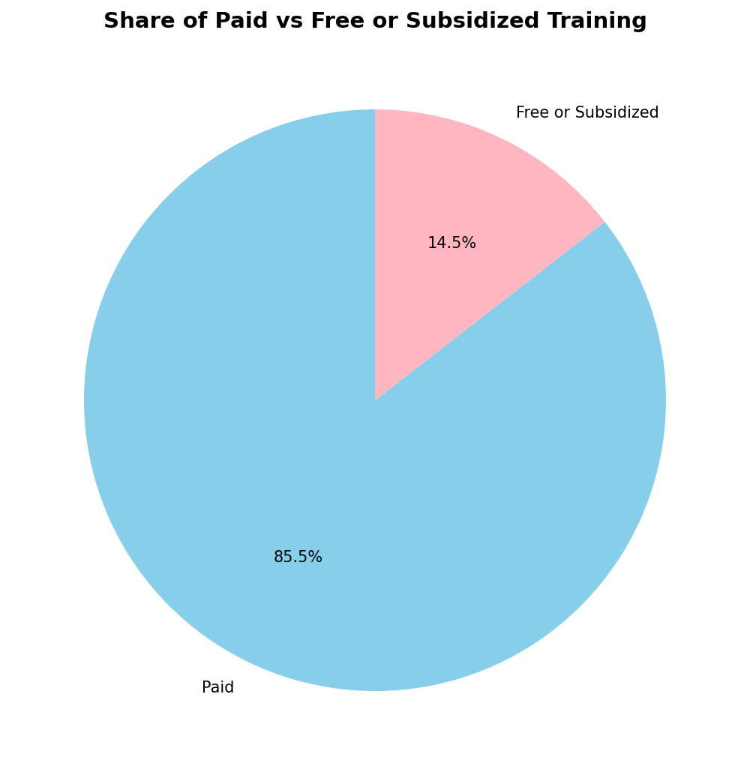
Figure 4: Share of Paid vs Free or Subsidized Training
As seen in the above chart, 85.5 percent of all training listings are paid, while 14.5 percent are free or subsidized. This reflects the dominance of the private training market. However, the stacked chart below goes deeper, showing exactly which service categories have free options available alongside paid ones.
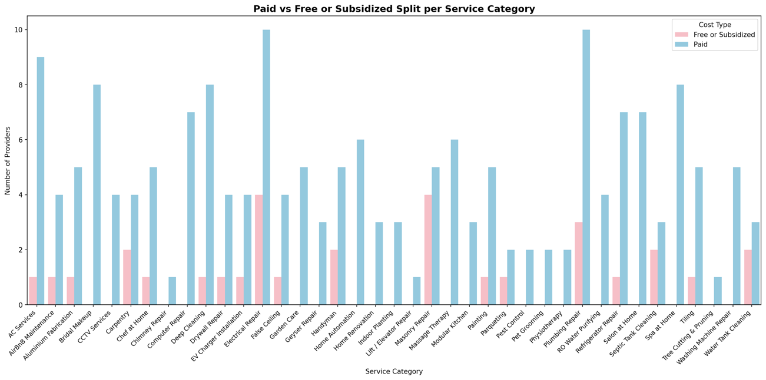
Figure 5: Paid vs Free or Subsidized Split per Service Category
Masonry Repair and Electrical Repair have the highest number of free or subsidized options, each offering four such programs. Services like Bridal Makeup, Salon at Home, and Chef at Home have no free training pathways at all, meaning aspiring workers in these categories must rely entirely on paid courses. This imbalance is worth addressing for platforms looking to recruit talent from lower-income backgrounds.

4.4 Most Active Training Providers
Several training providers appeared repeatedly across multiple service categories, indicating a broad and diversified training portfolio. The table and chart below list the top 10 most active providers based on the number of service categories for which they offer training.
Table 3: Top 10 Training Providers by Number of Service Categories Covered
No. | Institution Name | No. of Services Covered
1 | Apex Skills Academy | 12
2 | NMSPL | 11
3 | Trade Link Technical Training Institute | 11
4 | UTIOC | 11
5 | Global Reliance TC | 10
6 | Skill Nepal | 10
7 | Mobile Training Institute | 9
8 | Kamkhya OVS | 7
9 | KIEC | 7
10 | Technical Sewa | 7

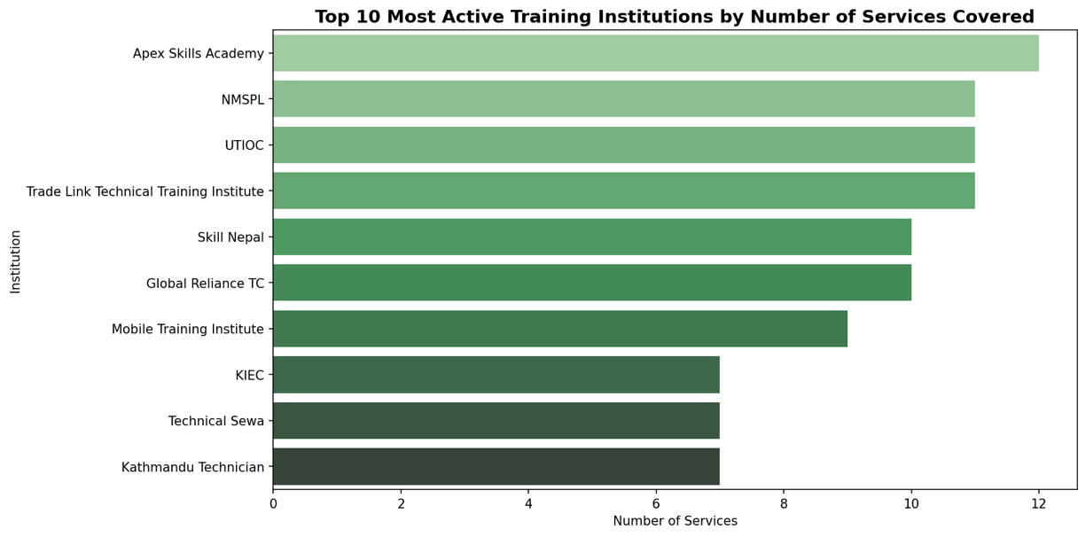
Figure 6: Top 10 Most Active Training Institutions by Number of Services Covered
Apex Skills Academy, Trade Link Technical Training Institute, NMSPL, Skill Nepal, and UTIOC are the most versatile providers, offering training across a wide range of technical and vocational services, making them key contributors to workforce development in the home services sector.

4.5 Service Categories with Limited Training Options
Although most service categories have multiple training providers, several areas remain underdeveloped, as shown in the chart of the ten categories with the fewest providers.
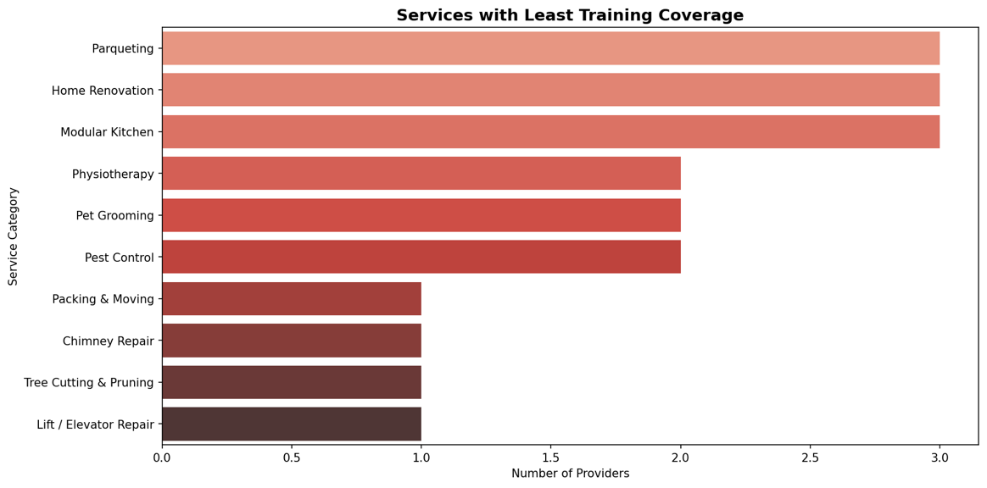
Figure 7: Services with Least Training Coverage
Packing and Moving has no identified training provider. Chimney Repair, Tree Cutting and Pruning, and Lift and Elevator Repair each have only one provider. Pet Grooming and Physiotherapy also have very limited options despite increasing demand, indicating clear gaps in training infrastructure.

5. Conclusion
The Kathmandu district has a reasonably developed training ecosystem for on-demand home services, with over 55 unique providers covering most service categories. Technical trades such as electrical repair, plumbing, masonry, and AC servicing enjoy the widest training coverage, while niche and emerging categories such as pet grooming, chimney repair, and lift maintenance are underserved.
The dominance of paid training reflects the commercial nature of the sector, but the presence of free or subsidized options through institutions like NMSPL, UTIOC, Talim Kendra, and F-Skill Nepal ensures that access to skill development is not entirely limited to those who can afford private tuition. Strengthening these free pathways and expanding coverage into underserved categories should be a priority for anyone building a talent pipeline for home service platforms in Nepal.

